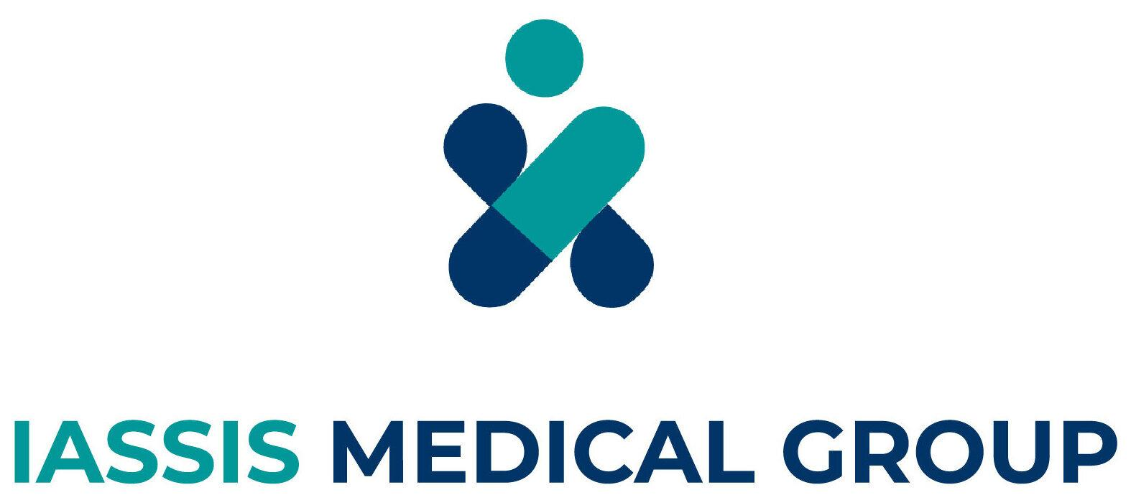

Junior Full Stack Web Developer
Location: Patras, Greece, on-site and/or hybrid
Job Type: Full-time, Permanent
Salary: Negotiable
Working for IASSIS MEDICAL GROUP

At IMG (IASSIS MEDICAL GROUP), we are stepping boldly into the era of digitalization by developing innovative web software products that enhance our operations across healthcare and aesthetics. Our mission is to evolve continuously, aligning with the rapid advancements in Digital Health and Aesthetics.

We are committed to harnessing the power of technology to upgrade internal workflows, improve patient experiences, and streamline services. Through our digital transformation strategy, our ultimate goal is to accelerate and revolutionize the way we support our customers, ensuring faster, smarter, safer, and more personalized care.

Job Description
We are seeking a motivated Junior Full Stack Developer to join our team in the newly established IT Department. You’ll assist in developing scalable web software solutions and be involved in the full software development life cycle. This is an excellent opportunity to grow your skills while working on innovative software web products. You’ll work closely with experienced developers who will mentor you and help you develop your technical capabilities.

Responsibilities:
- Learn and create JavaScript and Python-powered backend (Node.js, Next.js, Flask, etc.)
- Learn and create an HTML and JavaScript-powered frontend (React.js)
- Learn to create and manage databases and API integrations (PostgreSQL, MongoDB)
- Learn and develop software infrastructure in serverless environments
- Learn and develop on AWS/GCP
- Assist in implementing new features and designs in collaboration with the design team
- Identify and fix issues and bugs in the codebase
- Contribute to technical documentation
- Stay up-to-date with the latest web development trends and technologies
- Learn and work with Agile methodology, including sprint planning, stand-ups, and retrospectives

Company Values

Integrity
Say What You Think
We're committed to being honest and transparent. We consistently deliver high-quality products and content by being open with one another, even when it's tough. We always strive to go above and beyond for our customers and colleagues.

Innovative
Solve a real problem
We use data and intelligence to guide our decisions, focusing on the core problem rather than the surrounding distractions. We don't need to reinvent the wheel; we just need to solve problems people genuinely care about in new ways. Our goal is to create value for both our customers and the business, without being limited by what we've done before or what others are currently doing.

Ambitious
Shoot for the moon
We hold ourselves to the highest standards, paying meticulous attention to every detail. We concentrate on solving problems with effective results and are driven to deliver best-in-class experiences for our customers. We push ourselves and our colleagues in our quest for excellence, and we expect the same level of commitment in return.

Team Players
Value Every Voice
We value working together as a team and are always polite and helpful to both colleagues and customers. We are committed to giving and receiving continuous feedback and remain open to criticism. We believe in the importance of collaboration, constant learning, and respectful interactions.

Requirements
Essential:
- BSc Degree in Computer Science or similar (the candidate could also be an undergraduate student with her/his last obligations regarding studies)
- Knowledge of HTML, JavaScript, and CSS
- Knowledge of Python
- Familiarity and/or experience with REST APIs
- Basic experience with frontend technologies like React, CSS
- Understanding of relational databases, specifically PostgreSQL and MySQL
- Proficiency with Git and GitHub
- Appreciation for clean and well-documented code
Desirable:
- Familiarity with backend development solutions such as Node.js, Next.js, or Flask
- Understanding of continuous delivery processes and technologies (e.g., Docker, Jenkins)
- Understanding of testing principles
- Familiarity with NoSQL databases, such as MongoDB

Benefits
- Competitive salary and benefits package (e.g., bonus)
- Opportunities for professional development and growth
- Flexible working, with some options for remote work
- Dynamic and collaborative work environment
- Access to cutting-edge technology and tools
- Opportunity to work on exciting and innovative projects
- Chance to join a business that is disrupting an industry

How to Apply
If you feel like you are the perfect candidate and could make a significant contribution to IASSIS MEDICAL GROUP, please send a CV and cover letter to hr@img.com.gr (stating what you can contribute to Iassis Medical after joining us) in PDF format only.
Please note that all offers are subject to eligibility to work in Greece and the provision of satisfactory references. At IMG, we recognize the value of a diverse team and are committed to encouraging applications from people with varied experiences, perspectives, and backgrounds. Reasonable adjustments are available to support candidates through the application and interview process.

Other
Application Question(s):
- Are you based in Greece and hold the full right to work there?
Language:
- English (Required)

