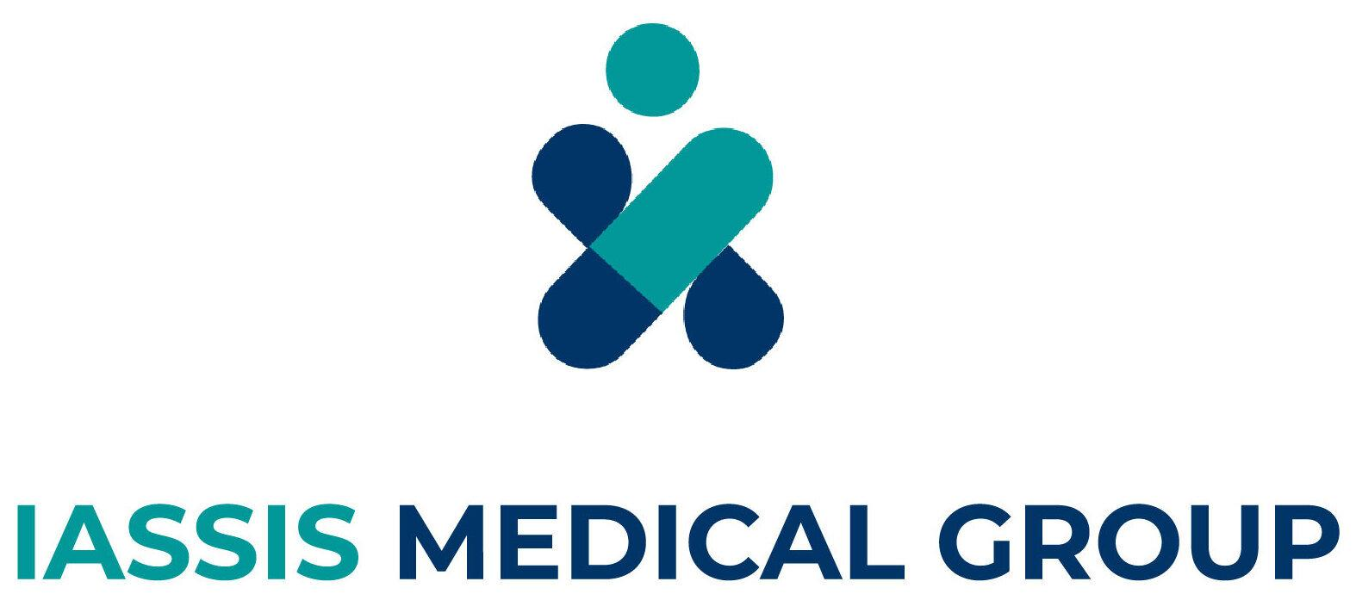

WordPress Web Developer
Location: Patras, Greece
Job Type: Full-time, Permanent
Salary: Negotiable
Working for IASSIS MEDICAL GROUP

At IMG (IASSIS MEDICAL GROUP), we are stepping boldly into the era of digitalization by developing innovative web software products that enhance our operations across healthcare and aesthetics. Our mission is to evolve continuously, aligning with the fast-paced advancements in Digital Health and Aesthetics.

We are committed to harnessing the power of technology to upgrade internal workflows, improve patient experiences, and streamline services. Through our digital transformation strategy, our ultimate goal is to accelerate and revolutionize the way we support our customers, ensuring faster, smarter, safer, and more personalized care.

Job Description
We are looking for a motivated WordPress Web Developer to join our team in the newly formed IT Department. You’ll be responsible for managing and maintaining 10 webpages that are related to IASSIS MEDICAL GROUP through WordPress to support visibility growth. This is an excellent opportunity to grow your skills while working on innovative web products. You’ll work closely with experienced developers who will mentor you and help you develop your technical capabilities.
- Management and maintenance of 10 webpages that have been built with the WordPress CMS
- Management and updates of WordPress plugins and themes
- Installation, setup, and optimization of Google Tag Manager, Facebook Pixel, Google Analytics, and Google Console
- Resolution of technical issues, performance, and security improvements
- Management of backup & recovery procedures
- Support and optimization of SEO-friendly settings
- Woocommerce management (uploading new offers - frequency 1-2 times/month)
- Experience with API integrations & tracking scripts
- Familiarity with speed optimization tools (Cache Plugins, CDN, Image Optimization)
- Understanding of SEO techniques and website speed
- Troubleshooting and debugging skills

Company Values

Integrity
Say What You Think
We're committed to being honest and transparent. We consistently deliver high-quality products and content by being open with one another, even when it's tough. We always strive to go above and beyond for our customers and colleagues.

Innovative
Solve a real problem
We use data and intelligence to guide our decisions, focusing on the core problem rather than the surrounding distractions. We don't need to reinvent the wheel; we just need to solve problems people genuinely care about in new ways. Our goal is to create value for both our customers and the business, without being limited by what we've done before or what others are currently doing.

Ambitious
Shoot for the moon
We hold ourselves to the highest standards, paying meticulous attention to every detail. We concentrate on solving problems with effective results and are driven to deliver best-in-class experiences for our customers. We push ourselves and our colleagues in our quest for excellence, and we expect the same level of commitment in return.

Team Players
Value Every Voice
We value working together as a team and are always polite and helpful to both colleagues and customers. We are committed to giving and receiving continuous feedback and remain open to criticism. We believe in the importance of collaboration, constant learning, and respectful interactions.

Requirements
Essential:
- Deep knowledge of WordPress CMS
- Knowledge of HTML, PHP, JavaScript, and CSS
- Familiarity and/or experience with API integrations
- Basic experience with frontend technologies like CSS
- Understanding of relational databases (MySQL)
Desirable:
- At least 2 years of experience in the development and management of WordPress-related webpages

Benefits
- Competitive salary and benefits package (e.g., bonus)
- Opportunities for professional development and growth
- Flexible working, with some options for remote work
- Dynamic and collaborative work environment
- Chance to join a business that is disrupting an industry

How to Apply
If you feel like you are the perfect candidate and could make a significant contribution to IASSIS MEDICAL GROUP, please send a CV and cover letter to hr@img.com.gr (stating what you can contribute to Iassis Medical after joining us) in PDF format only. Including an accompanying portfolio with work samples in the CV is mandatory.

Please note that all offers are subject to eligibility to work in Greece and the provision of satisfactory references. At IASSIS MEDICAL GROUP, we recognise the value of a diverse team, and we are committed to and encourage applications from people with varied experiences, perspectives, and backgrounds. Reasonable adjustments are available to support candidates through the application and interview process.

Application Question(s):
- Are you based in Greece and hold the full right to work there?
Language:
- English (Required)

Other
Application Question(s):
- Are you based in Greece and hold the full right to work there?
Language:
- English (Required)

